Per guidance from the Office of Laboratory Animal Welfare (OLAW), the institution must verify researchers are maintaining accurate breeding records and that animal numbers are being captured and deducted against approved numbers in a timely manner.
Your Breeding Records
- ALL new pups must be counted by the time of first handling (i.e. first cage change). You may no longer wait until weaning.
- Numbers of pups can be estimated at first handling and then updated at the time of weaning if necessary
- The destination/disposition of all pups must be tracked

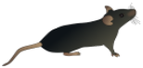Tracking Animal Use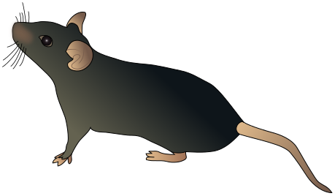

Below is a suggested heading that can be used to track the required minimal information for breeding records. It would work well with an excel database. Tracking individual animals helps to both satisfy Federal regulations, as well as institutional policy.
 |  |  | Current disposition
Animal ID# | DOB: | Gender | Date | Breeding, Transferred to protocol #, Found dead, or Euthanized
Benefits of Accurate Records

- Accurate, up to date information of your animal population
- All animals are accounted for; no animal is lost or forgotten
- Up to date, accurate annual review for census
- Appropriate weaning times are maintained
- Better tracking of per diem charges
- Compliance with all regulatory requirements

- If you have any questions about the federal guidance on breeding, or would like assistance with your breeding records, please contact the Office for Research Protections at (814) 865-1775 or email orp-iacuc@psu.edu. We have additional breeding templates available upon request.

