What to Expect on Lab Animal Inspections “The Big Five”

- Records are present and up to date
  - Cage cards accurate
  - Cages are marked appropriately when hazards are in use
  - Health alerts addressed and treatments recorded
  - Breeding records up to date
  - Surgical, post-procedural, and post-surgical records up to date
  - Controlled substance records
  - Biohazard training records
- Special husbandry provided by the research personnel is completed and recorded on the daily care sheet posted in the animal room
- Expired lab articles are disposed of
  - Food
  - Disinfectant
  - Surgical supplies
  - Any substance administered to animals (i.e. drugs, anesthetics, saline, ointment, etc.)
- General lab cleanliness
  - Equipment stored off floor
  - Trash is disposed of in the proper receptacle (i.e. sharps, carcasses, general waste)
  - Work surfaces and equipment cleaned and disinfected after animal use
  - Porous surfaces should be avoided (i.e. cardboard, untreated wood), as they cannot be adequately sanitized
- General lab safety
  - Exits and safety equipment not blocked
  - Safety equipment is certified
  - Proper PPE worn by all lab users
  - All secondary containers are appropriately labeled with their contents and, if applicable, their expiration dates
  - ABSL-2 Animal Room Notification Sheet on animal room door is updated to reflect the hazards currently being used

In accordance with PHS policy, “the IACUC must conduct inspections of facilities at least once every six months”. The following information is designed to inform investigators of different items the IACUC will be checking at each inspection. This is intended to provide informational guidelines; not all sections may apply to your lab, and other areas may have additional requirements not listed.
- Animal Care:
Animal care is the responsibility of the Principal Investigator (PI). The PI is responsible for all members of their lab to be trained in the appropriate animal care procedures. In accordance with The Guide for the Care and Use of Laboratory Animals, “Animals should be housed under conditions that provide sufficient space as well as supplementary structures and resources required to meet physical, physiologic, and behavioral needs.” Lab animals are provided with a standard caging system that uses standard animal food. Any deviation from this standard housing should be documented in IACUC protocols and justified. Examples of non-standard housing procedures include, but are not limited to:
- Single housed animals
- Metabolism caging
- Modified caging
- Special, nonstandard diet
- Special medicated water
- Fasting
See the recordkeeping section (1A) in this document for information on labeling cages for these non-standard procedures.
Other animal care items the IACUC checks are:
- Are cages overcrowded?
- Is the bedding overly soiled?
- Are cages weaned appropriately?
- Have health alerts been checked and treatments recorded?
- Do animals have proper enrichment?
- Is the census of the animals accurate for each cage?
Ensuring these animal care items are addressed provides quality environment for our animals.

1A. Recordkeeping
Breeding records:
Per guidance from the Office of Laboratory Animal Welfare (OLAW), the institution must verify researchers are maintaining accurate breeding records and that animal numbers are captured and deducted against approved numbers in a timely manner.
- ALL new pups must be counted by the time of first handling (i.e. first cage change). You may no longer wait until weaning.
- Numbers of pups can be estimated at first handling and then updated at the time of weaning if necessary
- The destination/disposition of all pups must be tracked
Below is a suggested heading that can be used to track the minimum required information on breeding records within an excel database. Tracking individual animals helps to both satisfy Federal regulations, as well as institutional policy.
 |  |  | Current disposition
Animal ID# | DOB: | Gender | Date | Breeding, transferred to protocol #, Found dead, or Euthanized

Weaning cards will often be placed on cages by the Animal Resource Program with dates that specify when animals must be weaned by. While it is important for investigators to know what animals need weaned at any given time, it is also important to wean cages by the date on these cards.

Surgical Records
Each surgical record book should have a copy of the surgical procedure from the IACUC protocol or a standard operating procedure (SOP) detailing the procedure for reference This is generally kept in the front of the record book.
It is also suggested to keep a surgical training log for individuals within the record book as well.
Each surgery must be logged. When performing only a few surgeries at a time, it is helpful to have a surgical record for each animal per page. Large cohorts of animals could have surgical records that include multiple animals per page (NOTE: All USDA covered species require individual surgical records per animal). These records must remain organized and kept in order, preferably by date.
Items in Your Surgery Log
Type of surgery (reference SOP in front of book) |  |  |  | Name of surgeon
The anesthesia type, dose, and route of delivery |  |  |  | The IACUC protocol number
Location surgery takes place |  |  |  | Date of procedure
Animal ID | Weight (g) | Anesthesia volume | Analgesia given |  | Notes about surgery
Post-Surgery
After surgery, post-surgical care must be performed in accordance with your approved IACUC protocol. Records must be kept documenting animal monitoring after surgery. These records may contain a SOP outlining how monitoring criteria is scored. Parameters for how monitoring criteria are scored is described in your IACUC protocol. Monitoring criteria can include body condition, hydration, animal weight, wound healing, locomotion, and animal’s overall behavior. Examples of information needed are given in the following table. As a best practice, monitoring for each animal should be inline.
Post-surgical care log
Animal ID | Date of check | Analgesia given | Notes
- Animals MUST be monitored until normal behavior and physical condition return. If there are surgical wounds, the wound must be healed, and sutures or wound clips removed before monitoring ends.
- A link to surgical recordkeeping forms can be found here: https://www.research.psu.edu/arp/surgery/record-keeping.html

Controlled Substance Records
In accordance with the DEA’s Practitioner’s Manual, “Each registrant who maintains an inventory of controlled substances must maintain a complete and accurate record of the controlled substances.” These records should reflect the source of controlled substances and track their use to final disposal. Below are some examples of organized documentation.
Keeping accurate records of controlled substances received is critical. When new vials of controlled drugs are received, it can be helpful to assign each vial with a unique ID number to simplify tracking it’s use (i.e.: Vial 1, 2, 3….). Below is a heading that can be used to track receipts and unique ID’s of controlled substance vials received:
Date received | Drug Name | Concentration (mg/mL, mg/tablet, etc.) | Volume | Number of containers | Lot #, Expiration Date | Vendor | Assigned Unique bottle ID Number(s) | Received by
Controlled substances need to be tracked for each individual vial owned
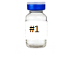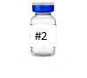
Each individual vial with a unique ID number should have a log to track individual usage. Below is a heading that can be used to track usage of each individual vial. Each time the vial is drawn from, this record must be updated. NOTE: If working with a new mixture or working solution that includes a controlled substance, the new mixture’s volume must also be tracked. An additional log sheet should be used to track this volume.
Drug Name: Initial Size (total mLs): Concentration (mg/mL): ____ Formulation (Cocktails): ______________
Date | Unique bottle ID # | Amount used (mL) | Amount remaining (mL) | IACUC# | Initials

- At any given time, the total volume of all controlled substances on hand should be known.
- When drugs have expired or been disposed of by Environmental Health and Safety, this date should also be recorded in your records

Cage Cards:
The Guide for the Care and Use of Laboratory Animals states the following information should be provided to identify animals for each cage:
- The source of the animal
- The strain or stock
- Name(s) of the responsible investigator(s)
- Pertinent dates (e.g. arrival date, birth date, surgical date, injection date, etc.)
- An ACCURATE IACUC protocol number (last 5 digits)
All cage cards must be complete and legible.

The Animal Resource Program (ARP) has a cage card template available for all lab animal users : https://www.research.psu.edu/arp/documents/breeding_cage_card_template.pdf
The standard ARP cage card is below. ARP will provide these preprinted upon request.
PI: | Dr. Doe | IACUC # | 00123
Species | Mouse
S/S/B: | (Stock/strain/breed) | Gender
 |  | 3
DOB: | Jan 1, 2020
- Cannula implant surgery: 4/15/2020
- Cannula infusion: 4/30/2020
EXAMPLE

Additionally, special husbandry items should be marked on cages as well. ARP has several cage cards to indicate these special cases. ALL special husbandry cards should have accurate dates and times.

Health alerts may be placed on cages as notification to veterinary staff. Once veterinary staff has checked these animals, they will contact investigators and occasionally prescribe treatments. If a treatment regimen is assigned, the treatment should be tracked on the back of the health alert:
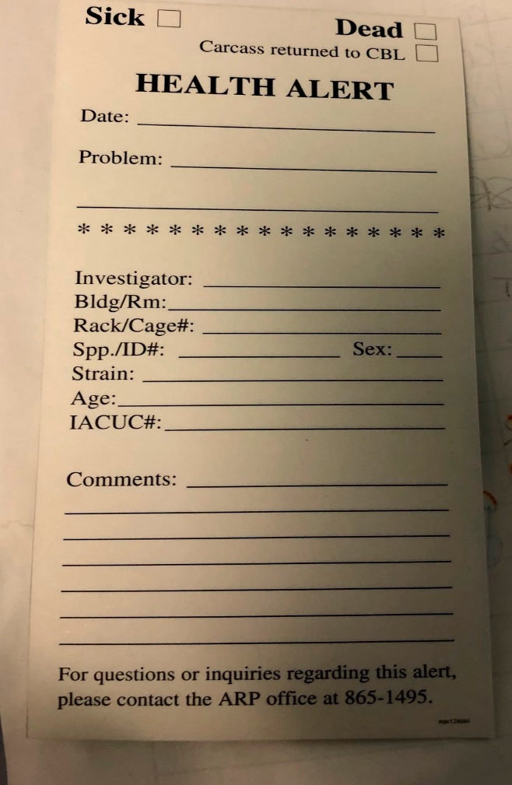

Additional Records:

Laboratory Animal Biohazard training is required to be taken by all users of biohazard in the lab animal setting. Once the initial course is taken by the lab from ARP, each PI will designate a “point of contact” person or POC. This may be the PI or another designated person in their lab such as a post doc, graduate student, or technician. Moving forward, the designated POC will become the labs training resource and be responsible for training new or existing lab members when new agents are added. Training materials and training spreadsheets will always be available to each lab in a SharePoint folder created for you by the ARP. Folder access will be limited to those who are approved for access such as the PI, POC, ARP, and ORP. After the initial training, training records will be maintained on SharePoint by the PI or POC and must be kept current. The IACUC will review these records during each semiannual inspection and may reach out to you for more information. These records should include the most recent date everyone in the lab has had the training. All practices that are addressed in the Animal Biohazard training are subject to inspection to ensure proper safe practices are occurring. For more information, contact the Animal Resource Program.
While not required (unless directed by the IACUC), it is also a good idea to keep track of other specialized training that has occurred (example include, but are not limited to: surgical procedures, lab specific training, retroorbital bleeding, cervical dislocation, etc..) in a logbook.
In addition to training records, many procedures require detailed SOP’s outlining their process. These SOP’s are kept in a logbook along with monitoring criteria that have been outlined in the IACUC protocol. Training records, SOP’s, and monitoring criteria are often kept together to create a comprehensive lab record that better explains the labs process to the IACUC.

1B. Other Record Keeping Items
Before inspections, it is encouraged to review IACUC protocols and to ensure all procedures are being performed as written in the most currently approved protocol. Items to consider include but not limited to:
- Have the scientific aims changed?
- How is my project funded currently?
- Is my research team accounted for on my protocol?
- Is my research team listed on all procedures they will perform? Are their experience logs up to date?
- Am I using a new animal strain?
- Has my experimental design changed?
- Have my procedures changed?
- New substances (ex: analgesia)
- Change in route substance is administered
- Change in substance concentration
- Change in volume needed for collections or injections
- Change in source of substance materials
- Altered method for behavioral testing
- Change in animal housing
- Change in diet
- Change in how animals are handled
- Change in surgical procedure

If any changes are needed to IACUC protocol changes, please submit a modification in CATS IACUC (iacuc.psu.edu). If you need assistance creating an amendment to your protocol, please contact the Office for Research Protection at 814-865-1775 or orp-iacuc@psu.edu

- Special Husbandry
Building:
Room #: |  |  |  | Month: |  |  |  |  |  |  |  |  | Year: | 20______
Species: |  |  |  | ¨ | JAN | ¨ | FEB | ¨ | MAR | ¨ | APR | ¨ | MAY | ¨ | JUN
PI: |  |  |  | ¨ | JUL | ¨ | AUG | ¨ | SEP | ¨ | OCT | ¨ | NOV | ¨ | DEC
PI Husbandry: YES or NO
DAILY TASKS: | 1 | 2 | 3 | 4 | 5 | 6 | 7 | 8 | 9 | 10 | 11 | 12 | 13 | 14 | 15
Record temperature (68°F-79°F)
Record humidity (30%-70%)
Daily observations (see below)
Feed /Top off feeders as needed
Re-Fill water bottles as needed
Spot/double change boxes as needed
Sweep floor (Monday-Friday)
WEEKLY TASKS:
Change static/vent boxes
Change water bottles
Clean tables/carts/surfaces
Clean hood (ATS & BSC)
Change disinfectant bottle
Mop floor & flush floor drain
Check light timer
BI-WEEKLY TASKS:
Change vent boxes (1 per cage)
Change wires
Dust vents/cans/door handles etc.
Clean vent rack filters
MONTHLY TASKS:
Clean room filters/exhaust grills
Clean cleaning implements
Change feed barrel
Change trash barrel
Clean door & door jamb & window
Clean & "Lime-Off" sink
Sanitize procedure tables
Daily Observations: | 1) Check feed levels |  |  |  |  |  | 3) Observe for "Health Alerts" to report
 | 2) Check water levels |  |  |  |  |  | 4) Check cage conditions & flag
PI Husbandry (Initials in the box)
If special husbandry (i.e.: food, water, cage change, etc..) is provided by the PI, please remember to sign off on the daily animal care log in the appropriate section for the day:

3. Expired Materials
The IACUC checks the expiration date on a variety of items to ensure a healthy, clean, and quality product is always provided to animals. Some examples of items that expire frequently are:
- Disinfectants (i.e. Virkon, Ethanol, Quatricide, Bleach)
- Feed
- Supplements
- Surgical supplies (i.e. suture material, sterile gloves, sterile needles)
- Analgesia/anesthesia (i.e. isoflurane, lidocaine, bupivacaine)
- Saline
- Autoclaved items (3-month shelf life)
Ensuring all supplies are not expired helps to prevent infections, ensure quality nutrition, and ensures some products will function as intended. Additionally, it is important to have all supplies properly labeled and stored. If items are expired and require specialized disposal, be sure to separate them from working supplies and clearly label “not for use until ready for disposal/pick-up”
Additionally, USDA regulations state, “Supplies of food and bedding must be stored in a manner that protects the supplies from spoilage, contamination, and vermin infestation.”

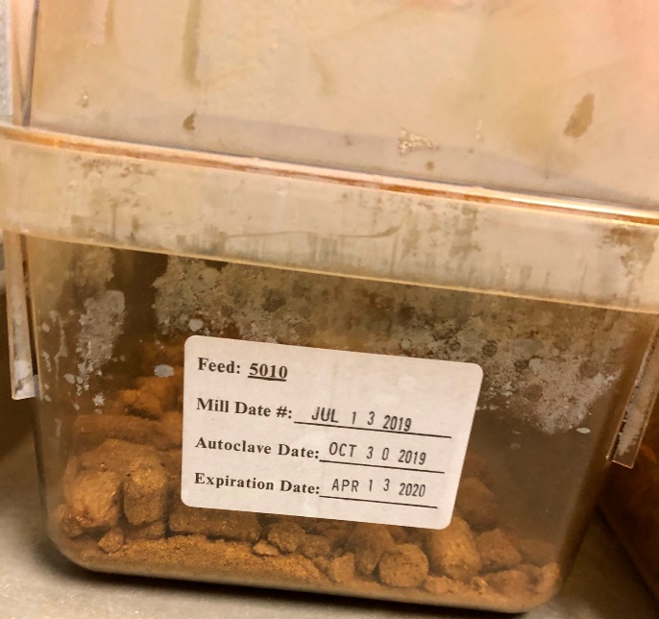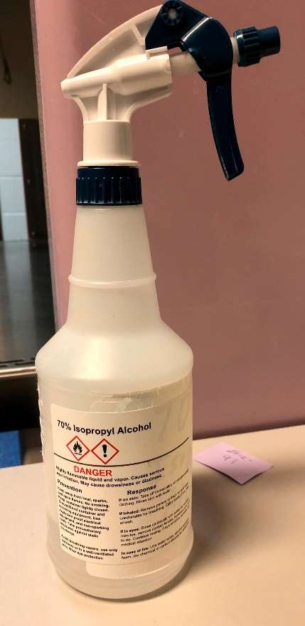
- Facilities/General Lab Cleanliness
The Guide for the Care and Use of Laboratory Animals outlines many requirements for the operation of an animal use facility. Some key points include:
- “Animals should be housed within temperature and humidity ranges appropriate for the species.”
- “The primary enclosure should provide a secure environment that does not permit animal escape….and are not detrimental to the health and research use of the animals.”
- “Walls…. should be free of cracks, unsealed utility penetrations, and imperfect junctions with doors, ceilings, floors, and corners.”
- Surfaces should be “smooth and sealed or painted.”

Examples of facilities issues that may need reported include:
Rusty tables, sinks or surfaces
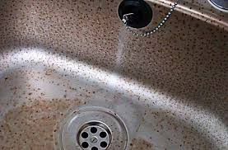

Cracks and chips in paint on walls, floors, and ceilings
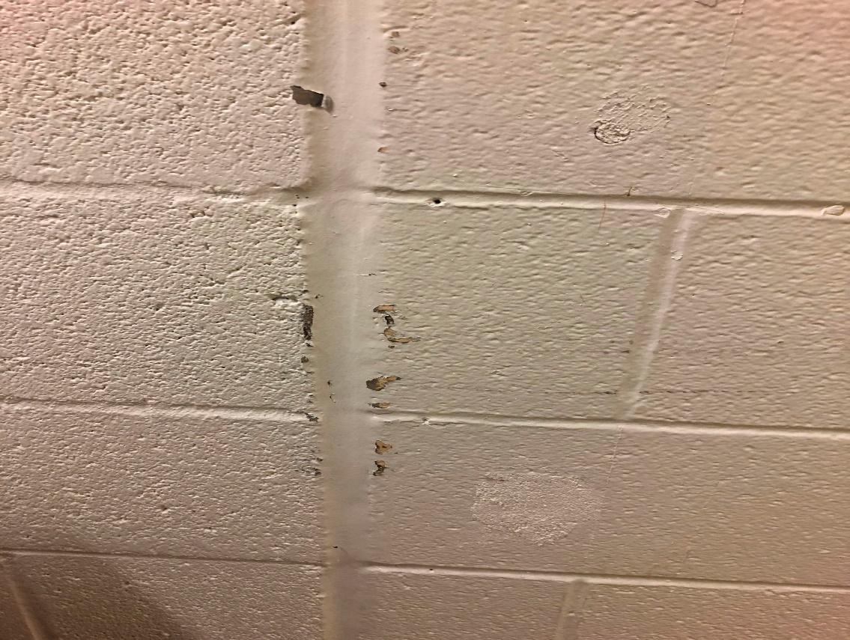
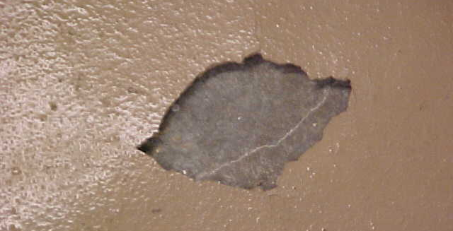
Exposed wires or electrical issues
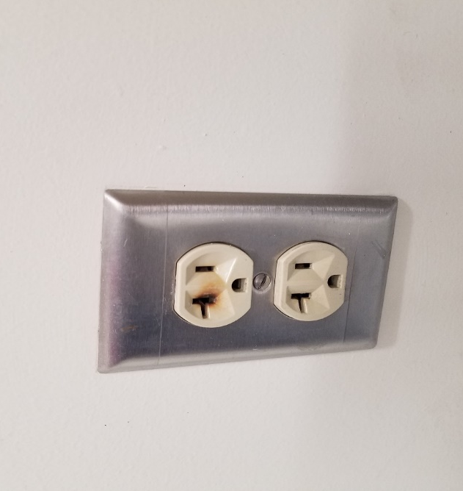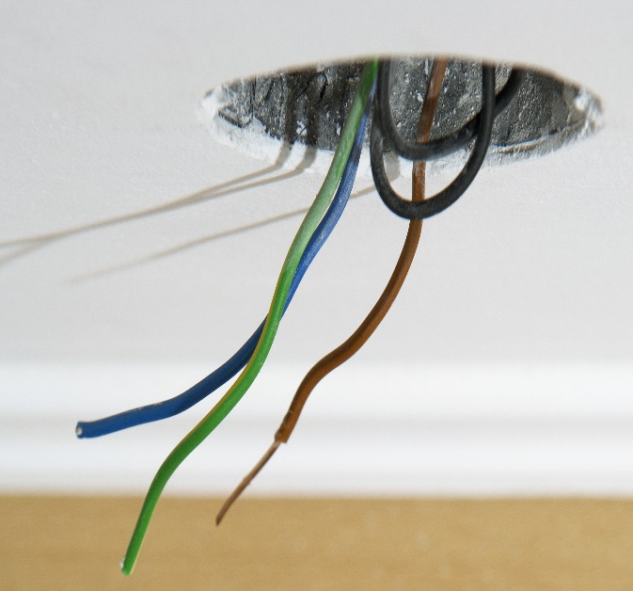

Areas covered in mold
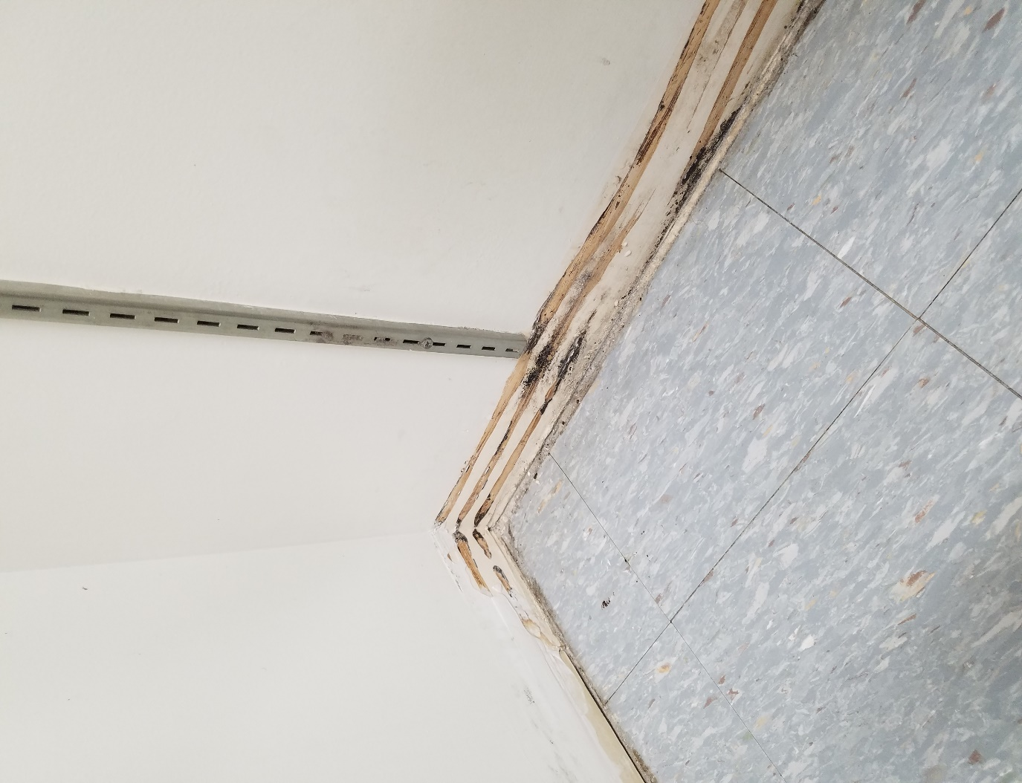

NOTE: While not all these issues are the responsibility of the investigator, it is important to note that these items may still compromise animal welfare and the safety of personnel working in the lab. If you notice any facilities issues, it is important that you report vivarium issues to the Animal Resource Program as soon as possible at (814) 865-1495. If there are any facilities issues within an investigator’s procedure space, they should contact the Facilities Coordinator for their building to submit a work order.
- In addition to facilities damage, animal use areas and laboratory spaces should be cleaned. The Guide states: “All components of the animal facility, including animal rooms and support spaces should be regularly cleaned and disinfected as appropriate to the circumstances and at a frequency based on the use of the area and the nature of likely contamination.”
It is important to keep all animal transfer stations, biosafety cabinets, lab tables, and other surfaces clean and disinfected when any animal work is completed. This protects the animals in the room as well as the personnel using the room.

5. General Lab Safety

The Guide requires all institutions maintain an occupational health and safety program. It is important to know the hazards working in animal use spaces and ensure all efforts are being made to mitigate any issues that may occur. Some practices to consider are:
- Ensure all exits are not blocked in the case of an emergency
- Wearing the appropriate PPE to avoid chemical and biological splashes, as well as prevent lab animal allergies. This information can be found with the specific requirements on the door of each animal room:
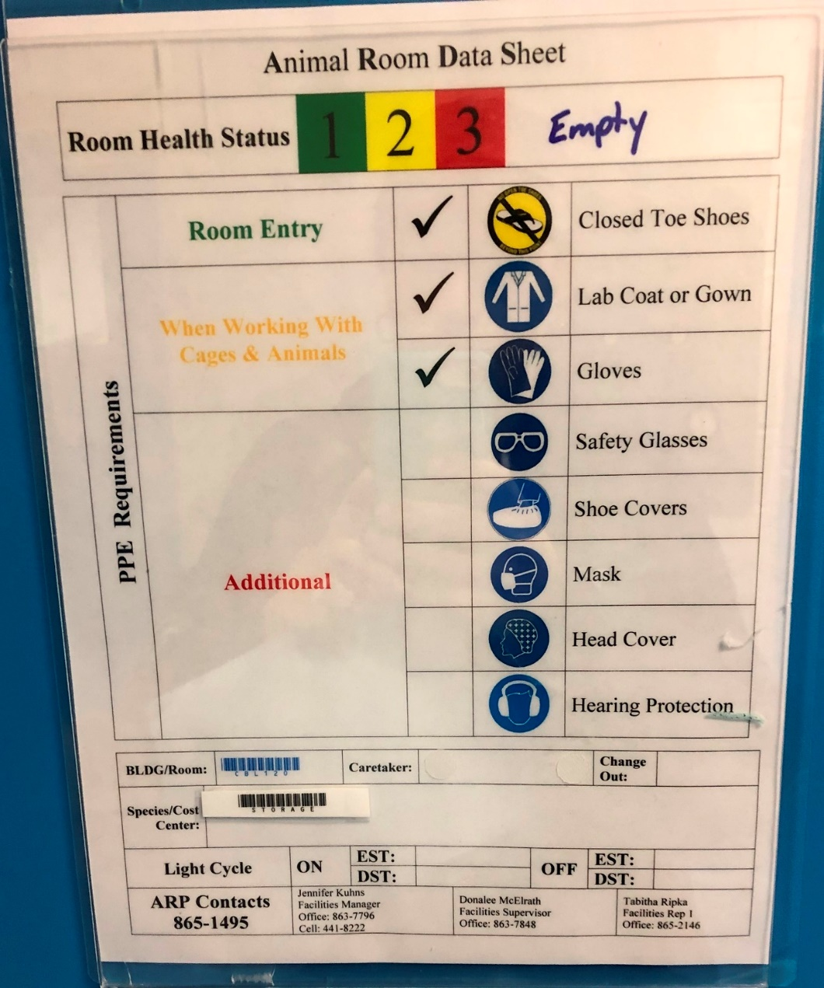
For PI managed spaces, PPE is the responsibility of the PI to provide. For questions regarding PPE within the animal facility, contact the Animal Resource Program.

- Ensuring emergency showers and eyewashes are not blocked and are inspected regularly
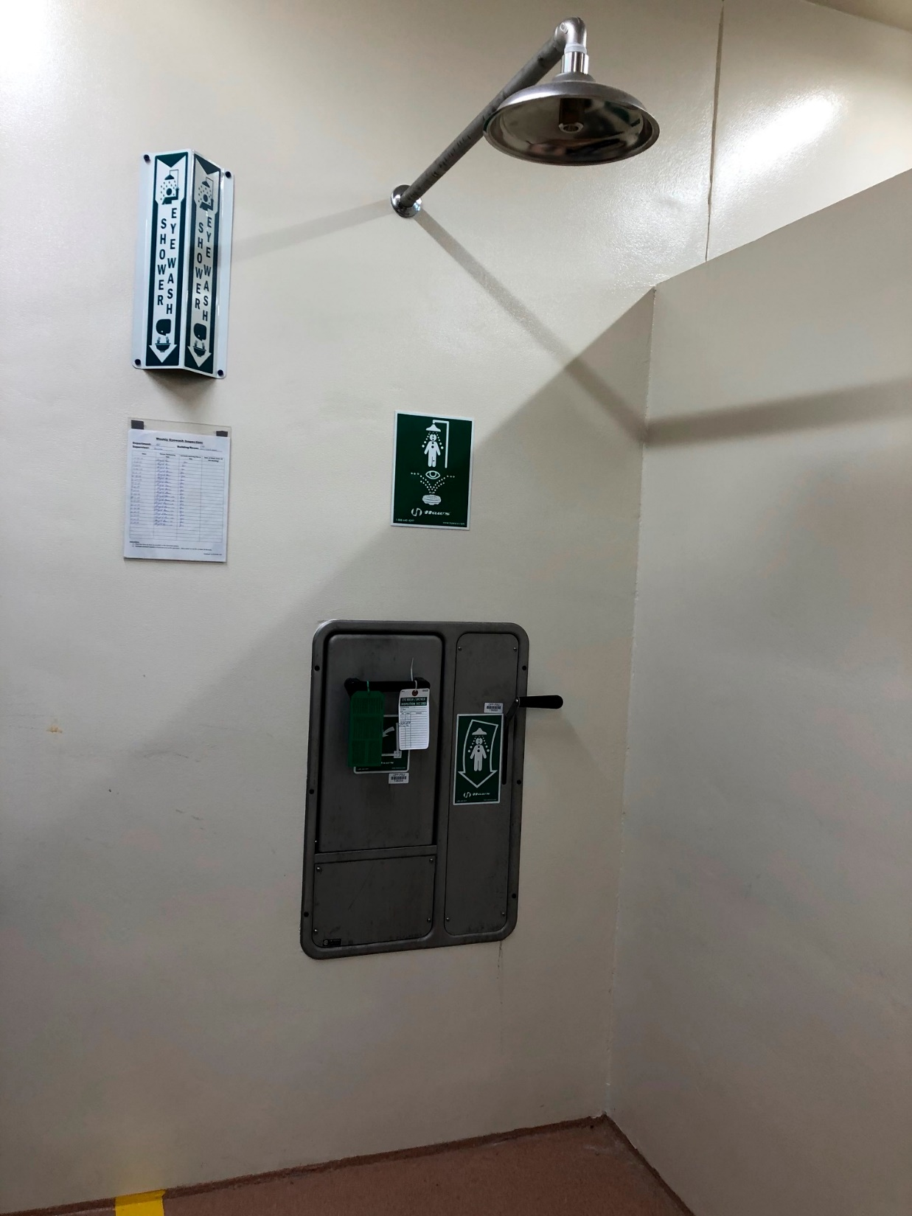

- Ensure all safety equipment is easily accessed and inspected. Examples include: Biosafety Cabinets, Fire extinguishers, Downdraft tables/anesthetic scavenging devices, etc.
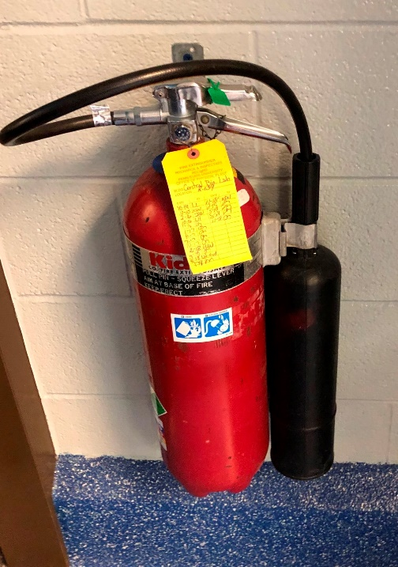

- For additional safety requirements to consider, you can find many documents outlining Lab safety requirements on Penn State’s Environmental Health and Safety’s website: https://ehs.psu.edu/laboratory-safety/guidelines. To address any concerns with lab safety equipment, contact EHS at (814) 865-6391.

- Ensure you are following all practices listed in the Animal/Biohazard Safety Protocol. This document is generated at the time of Biosafety protocol review, and is specific to the hazards and facilities you work with. To request a new copy of your Animal/Biohazard Safety Protocol, email orp-biosafety@psu.edu. An example of an Animal/Biohazard Safety Protocol is seen below:

Tamoxifen Contaminated Caging

Abbreviated Safety Protocol:

Hazard: Tamoxifen is a carcinogen. Tamoxifen is administered via injection, gavage, impregnated food or topically.

Exposure: Possible routes of exposure are via inhalation, ingestion, and accidental needle stick during administration.

If administered by injection use locking hub syringes (such as Luer-lock). Small amounts of Tamoxifen may be present in feces and urine for up to two days following administration. Therefore, the bedding may be contaminated and will need to be incinerated.

Low levels of Tamoxifen are present in the diet, so the risk of significant exposure is low. Food and particles of food in the bedding may contain Tamoxifen. Active drug may also be passed in the feces and urine. Therefore, the bedding may be contaminated and will need to be incinerated.

Safe handling procedures: Avoid procedures that expose personnel to bedding and food dusts. Wear rubber gloves and lab coat when handling food and during administration. Caretakers should work within a Biosafety Cabinet to collect bedding and waste food for disposal as Hazardous waste (bag the bedding and place in a Biohazard box for incineration).

Hazard Cage Card to place on cage:

Tamoxifen Feed/Injection/Topical (carcinogen)
Caretaker Precautions and PPE: Rubber Gloves and lab coat. Avoid exposure to bedding and dusts.

Cage/Bedding Handling: Collect/bag bedding & waste food in BSC. Place in Biohazard container.

Procedure Spaces
Any procedure space where animals are used outside of the ARP vivarium space must be documented in your IACUC protocol. Examples of procedure spaces include PI managed areas for euthanasia, surgical procedures, behavior procedures, terminal perfusions, imaging, etc. These areas are also subject to inspection semi-annually. Some common items checked for in these areas are:
- IACUC Guideline 17 is posted where users of the lab space can see. This guideline outlines whom individuals can contact if they feel there is an animal welfare concern. ALL PROCEDURE SPACES MUST DISPLAY GUIDELINE 17. A printable version can be found on ORP’s website: https://www.research.psu.edu/iacuc/policies
- Disinfectants and surgical items must not be expired
- Biosafety cabinets and fume hoods should have a valid inspection date (sticker should be present)

- Euthanasia stations should be labeled with appropriate instructions for using equipment:
To request a copy of euthanasia posters, please contact ARP at arp@psu.edu
Questions
In summary, this guide was designed to inform investigators of different items the IACUC will be checking at each inspection. This is intended to provide informational guidelines; not all sections may apply to your lab, and other areas may have additional requirements not listed. If you have any questions regarding any of the information contained in this guide, please contact the Office for Research Protections at 814-865-1775.

